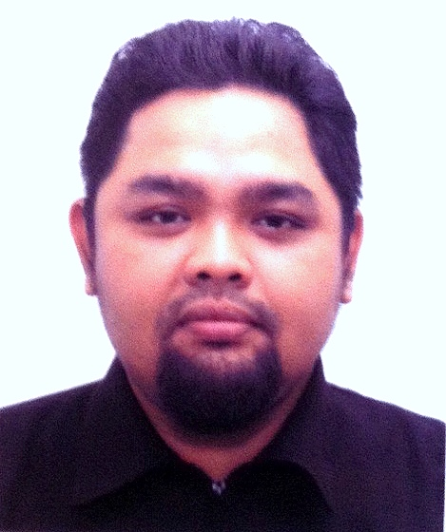
CONTACT DETAILS
Address : | 101, Pvd 1,  Perdana Villa Deluxe,  Jalan Perdana 2/1, Pandan Perdana,  55300 Kuala Lumpur
I/C No : | 790107-08-5905
Mobile Phone : | 012-6438133
E-Mail : | husnira@gmail.com

PROFESSIONAL EXPERIENCES
Company Name : | MM Global Sdn Bhd
Job Title : | Training Project Manager
Duration : | 2011 - 2013
Responsibility and Work Description: | Co developed Anti Terrorism Training module for civilians which is among the first of its kind in Malaysia.
Company Name : | Bostonweb College
Job Title : | International Student Office dept. (ISO)
Level : | Senior Executive
Duration : | 2010 - 2011
Responsibility and Work Description: | Responsible to manage international students’ affairs with Department of Immigration in Putrajaya. Managing special passes, overstays and approvals. Also engaged with negotiations regarding special cases and black listings
Company Name : | Orea Technologies Sdn Bhd
Job Title : | Corporate Training
Level : | Project Manager
Duration : | 2008 - 2009
Responsibility and Work Description: | - Project manager and proposal developer for INTERNATIONAL CYBER SKILL TRAINING IN NEW YORK, WASHINGTON DC AND BOSTON MASSACHUSETTS (MIT), UNITED STATES OF AMERICA.  - Managed training projects for University Malaya for high end IT training
Company Name : | Bostonweb Academy Sdn bhd
Job Title : | Corporate Training provider.  Under the Special Project Division, responsible for sales and project management on all business portfolios of the Bostonweb Group. (placements,training and college)
Level : | Project Manager
Duration : | 2007 - 2008
Responsibility and Work Description: | Achievements:  - Managed the Kementerian Keselamatan Dalam Negeri (KKDN) training account.  - Project manager for all training projects with KKDN worth RM 400,000.00.  - Managed the first oversea training (Melbourne,Australia) in the company.
Company Name : | Bostonweb Iplacements Sdn Bhd  An offline employment agency. A subsidiary of Bostonweb Academy sdn bhd
Job Title : | Business Development Consultant
Duration : | 2006 - 2007
Responsibility and Work Description: | Achievements:  - Apprentice training program-acquired the Takaful Malaysia accounts that involve training future employee. Worth RM 200,000.00 per session (3 months).
Company Name : | Zhulian Marketing (M) Sdn Bhd – Branch
Job Title : | Assistant Branch Manager
Duration : | 2004 - 2006
Responsibility and Work Description: | Co owned the branch license for Rawang district Assistant manager for Zhulian Rawang branch agency Manage sales, accounts, marketing and administration.  Achievements:  - Zhulian Rawang agency achieved RM 1 Million annual sales gross in second year of operation.  - First corporate sponsoring made in Zhulian (sponsored an incorporated company to distribute Zhulians product.)
Company Name : | VEE CAN Sdn Bhd
Job Title : | Business Development Consultant
Duration : | 2004
Responsibility and Work Description: | Co owned the branch license for Rawang district Assistant manager for Zhulian Rawang branch agency Manage sales, accounts, marketing and administration.  An event management company. A subsidiary of Cosmolex sdn bhd.  - Involve in event managements and corporate account managements.  - Managed the Sendayu Tinggi Corp. annual gala.  - Managed and MCed gathering for Persatuan Industri Kosmetik Bumiputera Malaysia at PWTC.
Company Name : | Cosmolex Sdn Bhd
Job Title : | Marketing & Training Executive
Duration : | July 2003 – January 2004
Responsibility and Work Description: | A marketing company for the NIKI Cosmetic line by ACC Industries sdn bhd. Working closely with owner of the NIKI label, Dato Kalthom Ithnin.  - Involve in training of the distributor of NIKI cosmetic in Business management aspects.  - Marketing and sales for the NIKI Cosmetics lines.
Company Name : | Saracos Sdn bhd  A cosmetic company with portfolio investor from Puncak Niaga berhad.focusing on local product with international expertise.
Job Title : | Training Executive
Duration : | January 2003 – Jun 2003
Responsibility and Work Description: | As training executive, my responsibility was to train the local product distributors regarding business knowledge. The trainings were held all over the country except Sabah and Sarawak.  My secondary responsibilities are market research and sales.
Company Name : | Ipoh Cargo Terminal
Job Title : | Trainee (Practical Training)
Duration : | 2002 - 2003

PERSONAL PARTICULARS
Date Of Birth : | 7 Jan 1979 | Nationality : | Bumiputera
Gender : | Male | Marital Status : | Single

EDUCATIONAL BACKGROUND

Level | : | Bachelor Degree in Business Administration with Honors (Maj. International  Business)
Name of Institution | : | Universiti Utara Malaysia (UUM)
Year | : | 2002
Level | : | Pra-U
Name of Institution | : | Matrikulasi UUM
Year | : | 1998
Level | : | Sijil Pelajaran Malaysia (SPM)
Name of Institution | : | Maktab Rendah Sains Mara Kuala Berang,Terengganu.
Year | : | 1996
Level | : | Penilaian Menengah Rendah (PMR)
Name of Institution | : | Sek .Men. Keb. Tok Perdana,Sitiawan Perak
Year | : | 1994

LINGUISTIC CAPABILITY
English | Fluent in reading, writing and speaking
Bahasa Malaysia | Fluent in reading, writing and speaking (mother tongue)

WORKING SKILLS

Training module development (short & long term)
Government Training Proposal Writing
Training Project Management and Costing. Gov and Corporate Sales
Training Need Analysis
International Training Management.

IT KNOWLEDGE

(Intermediate) Microsoft Office Applications
Hardware Configurations
Internet Data Mining Skills.

SPECIALIZE SKILLS @ FORTE

- Project Management. (Governments and Corporate Trainings, Oversea Training Projects)
- Marketing
- Research and Strategic Management
- International Student Management

PERSONAL ATTRIBUTES

Easy to adapt to new environment - fast learner
Hard working
Willing to learn new things
Dependable and energetic
Sense of responsibility
Creative and resourceful

INTEREST / EXTRA COCURICULLAR ACTIVITIES

- Certified Silat Instructor (Per. Silat Gayung Pasak Kebangsaan Malaysia)
- University Certification On Sport Science (Handball)
- Reading, Internet surfing, Martial Arts, Golf.

REFEREES

En Idris Md Kassim
Executive Director
HOD Special Project Div. Bostonweb Group
012 4945900

Pn.Ragayah Hamzah
Zhulian agency (Rawang)
012-5287435

SUPPLEMENTARY

Willing to be Relocated | : | Yes
Possess Own Transport | : | Yes
Expected Monthly Salary | : | RM 4300 - RM 4900
Availability | : | Immediately

